Campus Vote – System Walkthrough & User Guide
This document explains the Campus Vote Governance & Voting Platform. The system has two main ends: the Student Interface and the Admin Interface. Below is a step-by-step explanation of how the system works, using the provided screenshots.

Part 1: The Student End
This is the side that regular students (voters) use to register, log in, view elections, and vote.
Step 1: Account Creation (Registration)
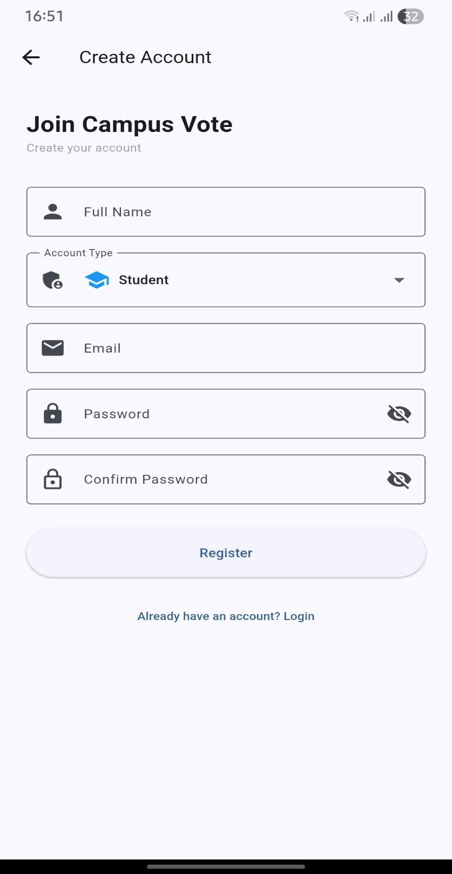
When a student first opens the app, they land on the login screen, but they don’t have an account yet.
- Action: The student clicks "Register" (as seen on the login screen or the prompt "Don't have an account? Register").
- Screen shown: The Create Account screen.
- Details required:
  - Full Name: The student's legal name.
  - Account Type: A dropdown set to "Student" (because admins are created separately).
  - Email: A valid campus email address.
  - Password & Confirm Password: Secure login credentials.
- Outcome: The student taps Register and is redirected to the Login screen.

Step 2: Login
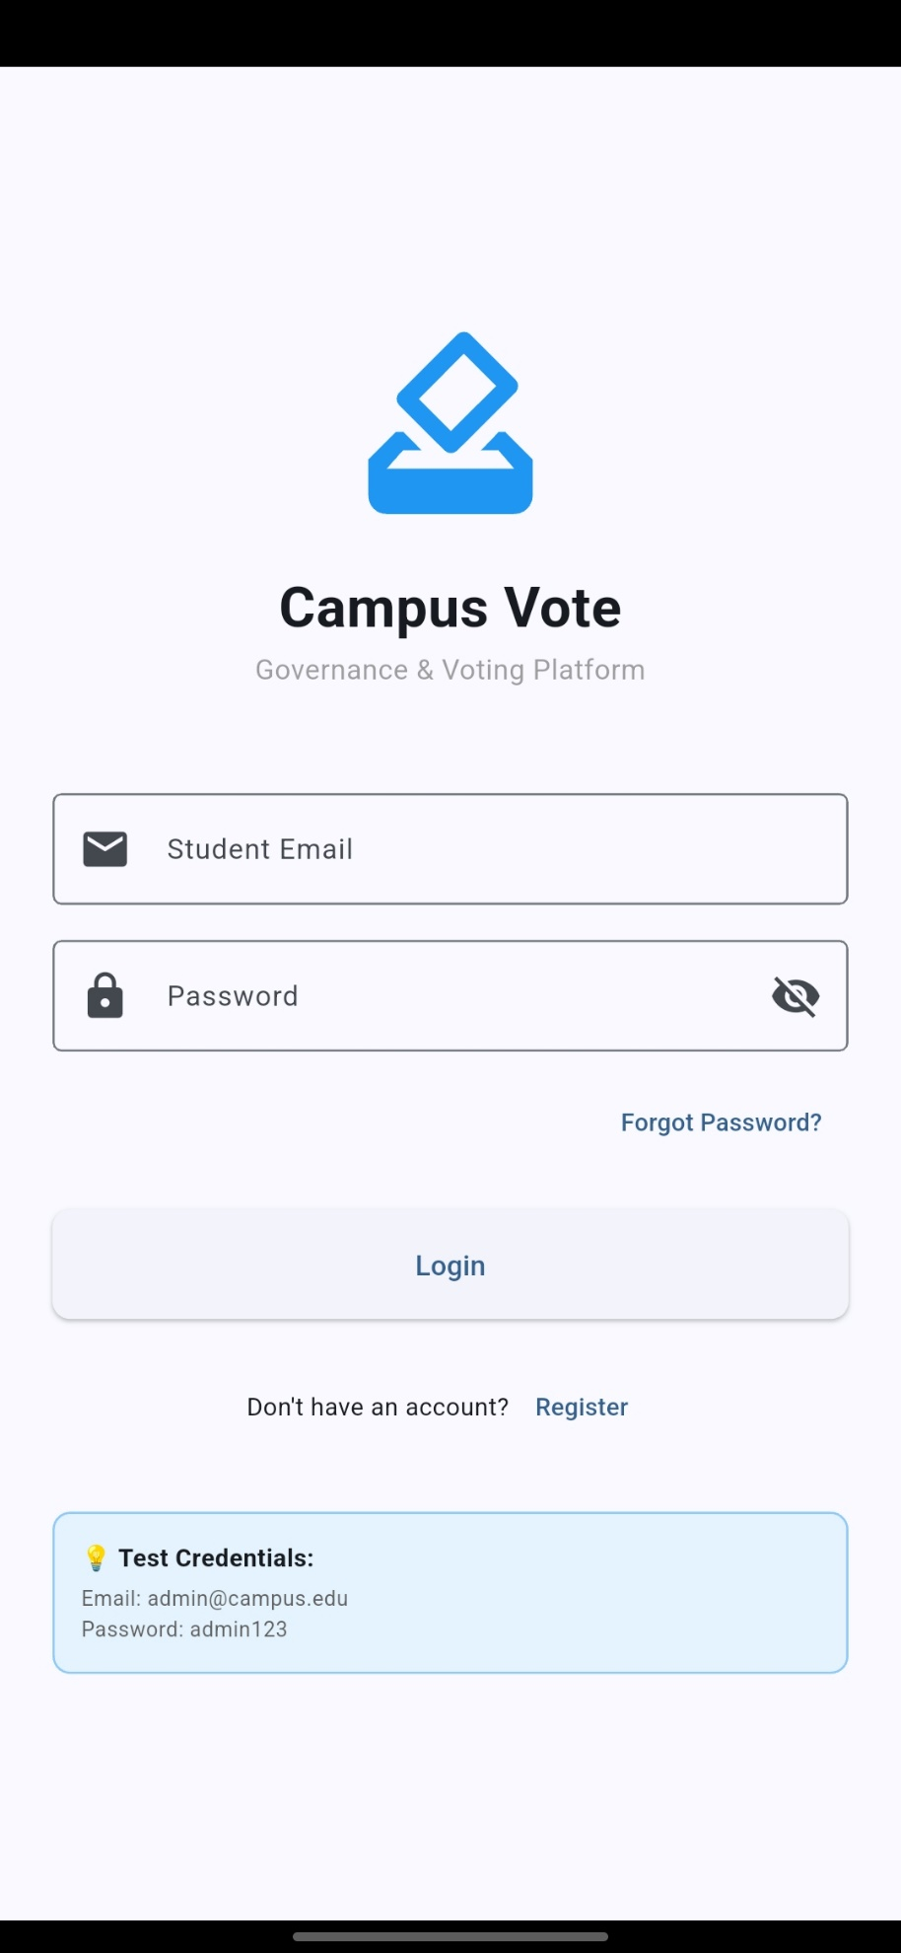
- Screen: The main Login screen with the "Campus Vote" branding.
- Credentials: The student enters their registered Student Email and Password.
- Note: There is a "Forgot Password?" link for recovery.
- Demo Access: The screen also displays test credentials (admin@campus.edu / admin123), though these are strictly for the admin side during testing.

Step 3: The Student Dashboard
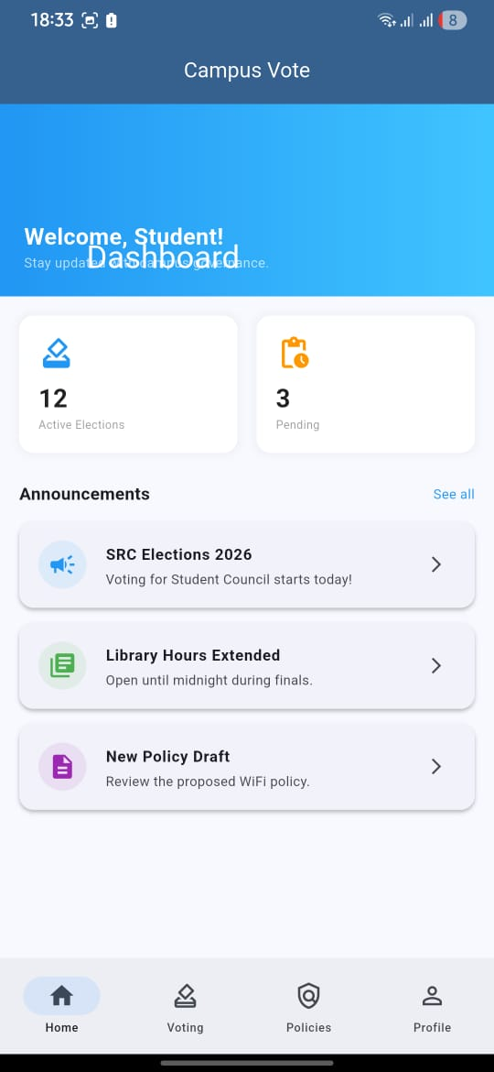
Once logged in, the student sees a personalized Dashboard.
- Welcome Message: "Welcome, Student! Stay updated on the Dashboard."
- Announcements: A central feed shows critical updates:
  - Active Elections: (e.g., "Voting for Student Council starts today!").
  - General News: (e.g., "Library Hours Extended").
  - Policy Drafts: (e.g., "Review the proposed WiFi policy").
- Bottom Navigation: The main menu has four tabs:
  - Home (Dashboard)
  - Voting (Election categories)
  - Policies (Campus rules)
  - Profile (User settings)

Step 4: Browsing Elections
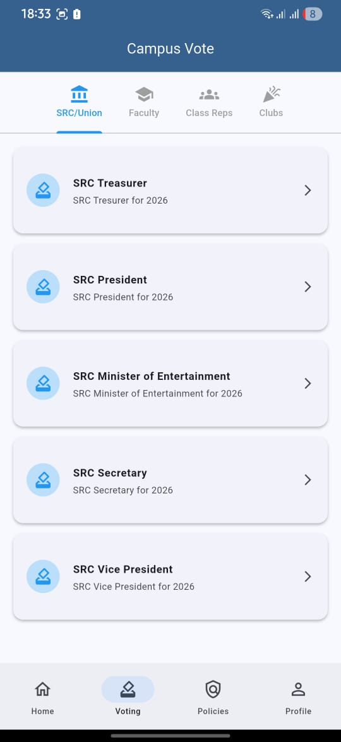
When the student taps the Voting tab (or the "Home" screen election icons), they see the election categories.
- Categories Listed:
  - SRC/Union
  - Faculty
  - Class Reps
  - Clubs
- Active Races: Under the SRC category, the following positions are displayed:
  - SRC Treasurer
  - SRC President
  - SRC Minister of Entertainment
  - SRC Secretary
  - SRC Vice President

Step 5: Casting a Vote
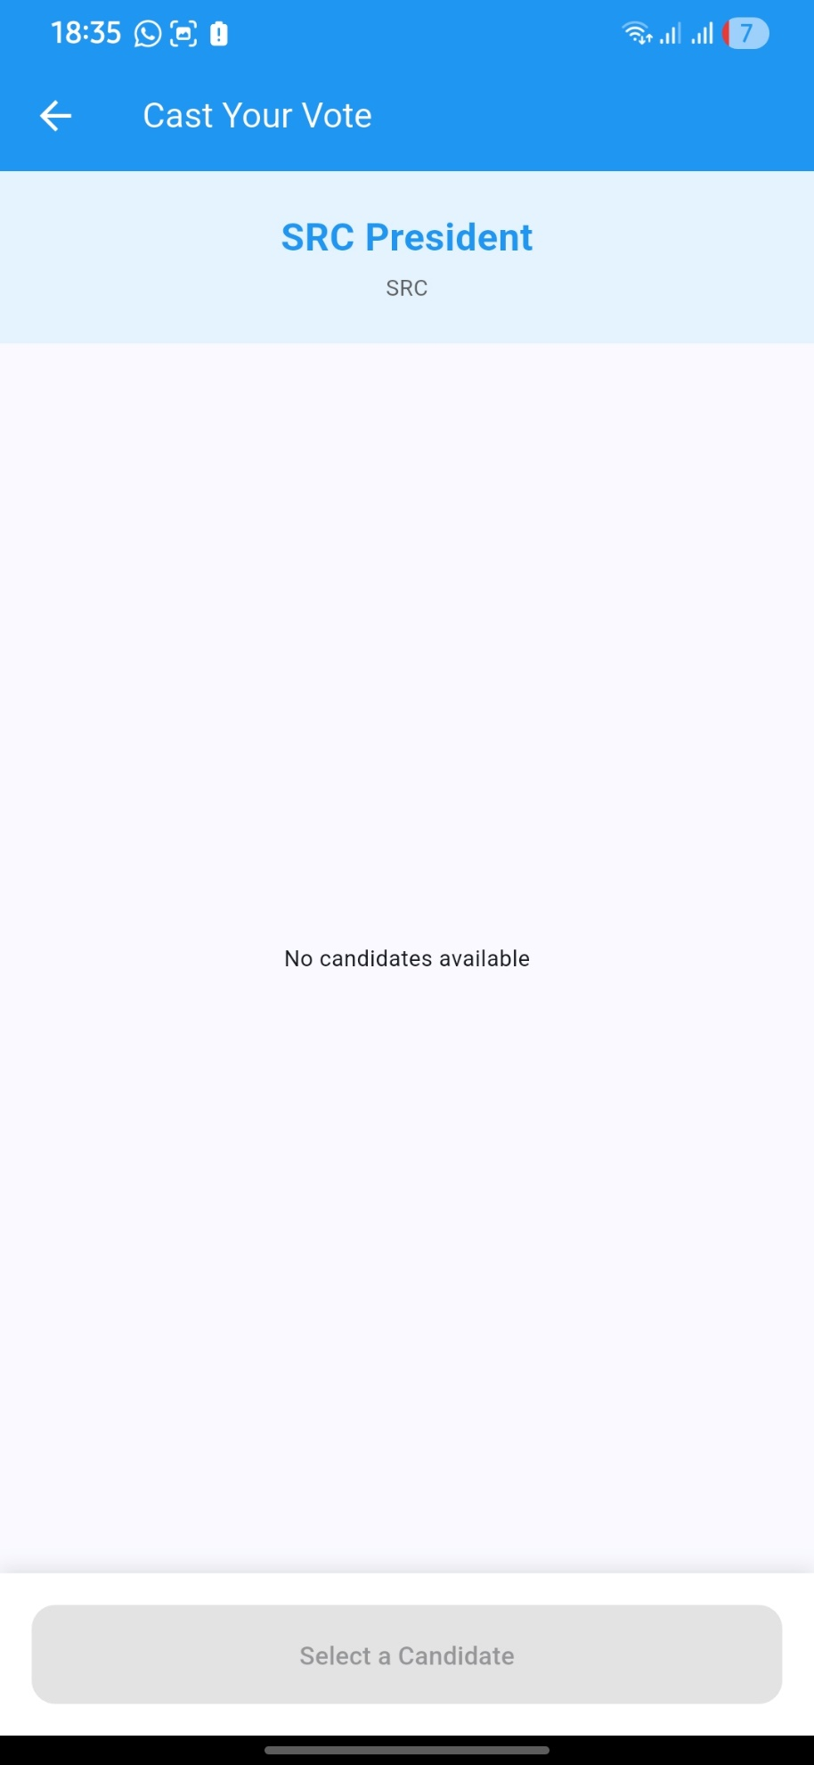
The student taps on a specific position to vote.
- Example Screen: SRC President.
- Candidate List: The system displays the candidates running. (Note: The provided screenshot shows "No candidates available," meaning the admin has not yet added candidates, or the election hasn't started).
- Selection: If candidates were available, the student would select one and confirm their vote.

Step 6: Viewing Policies
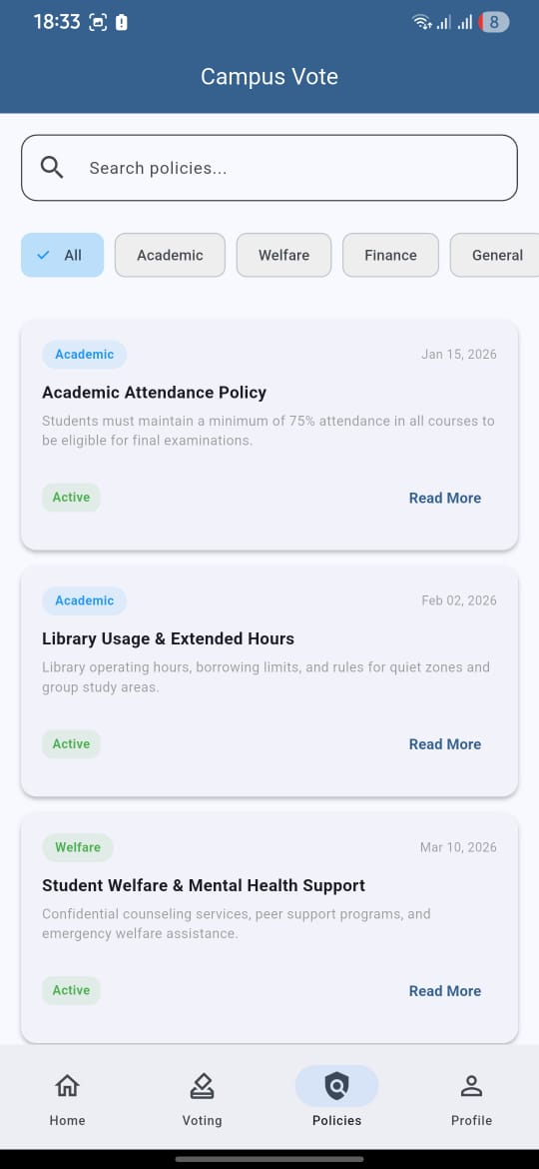
The student uses the Policies tab to stay informed about campus regulations.
- Search Bar: Allows searching by keyword.
- Categories: A filter bar includes All, Academic, Welfare, Finance, and General.
- Document View: Each policy card shows its Status (e.g., Active) and a Read More button.
  - Examples: Academic Attendance Policy (75% rule), Library Usage, Student Welfare & Mental Health Support.

Part 2: The Admin End
This is the administrative panel used by the election commission. It requires a pre-set admin account.
Step 1: Admin Login

- The administrator navigates to the same Login screen but enters specific admin credentials.
- Credentials Used: admin@campus.edu | admin123

Step 2: The Admin Dashboard
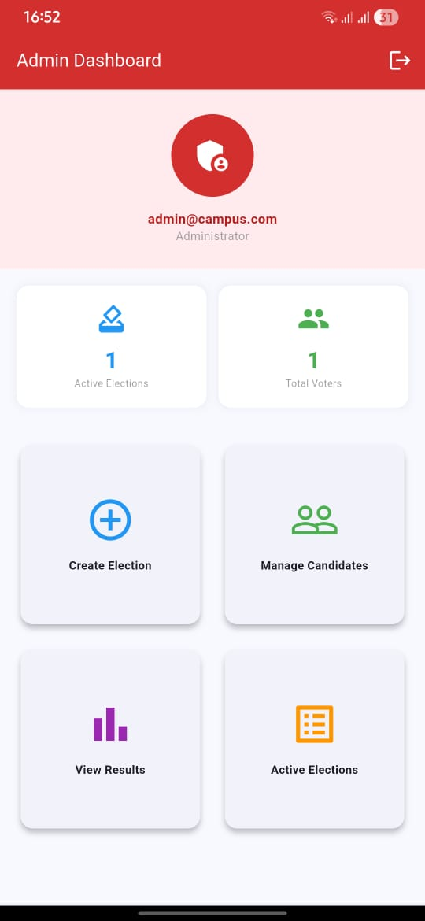
Upon successful login, the admin sees a high-level control panel.
- Header: Confirms the login ("admin@campus.com") and role ("Administrator").
- Statistics Cards: Quick overview showing "1 Active Elections" and "1 Total Voters".
- Action Buttons: Three main management functions:
  - Create Election
  - Manage Candidates
  - View Results
- Active Elections Section: A list showing the currently running election (e.g., "SRC Elections 2026").

Step 3: Creating an Election
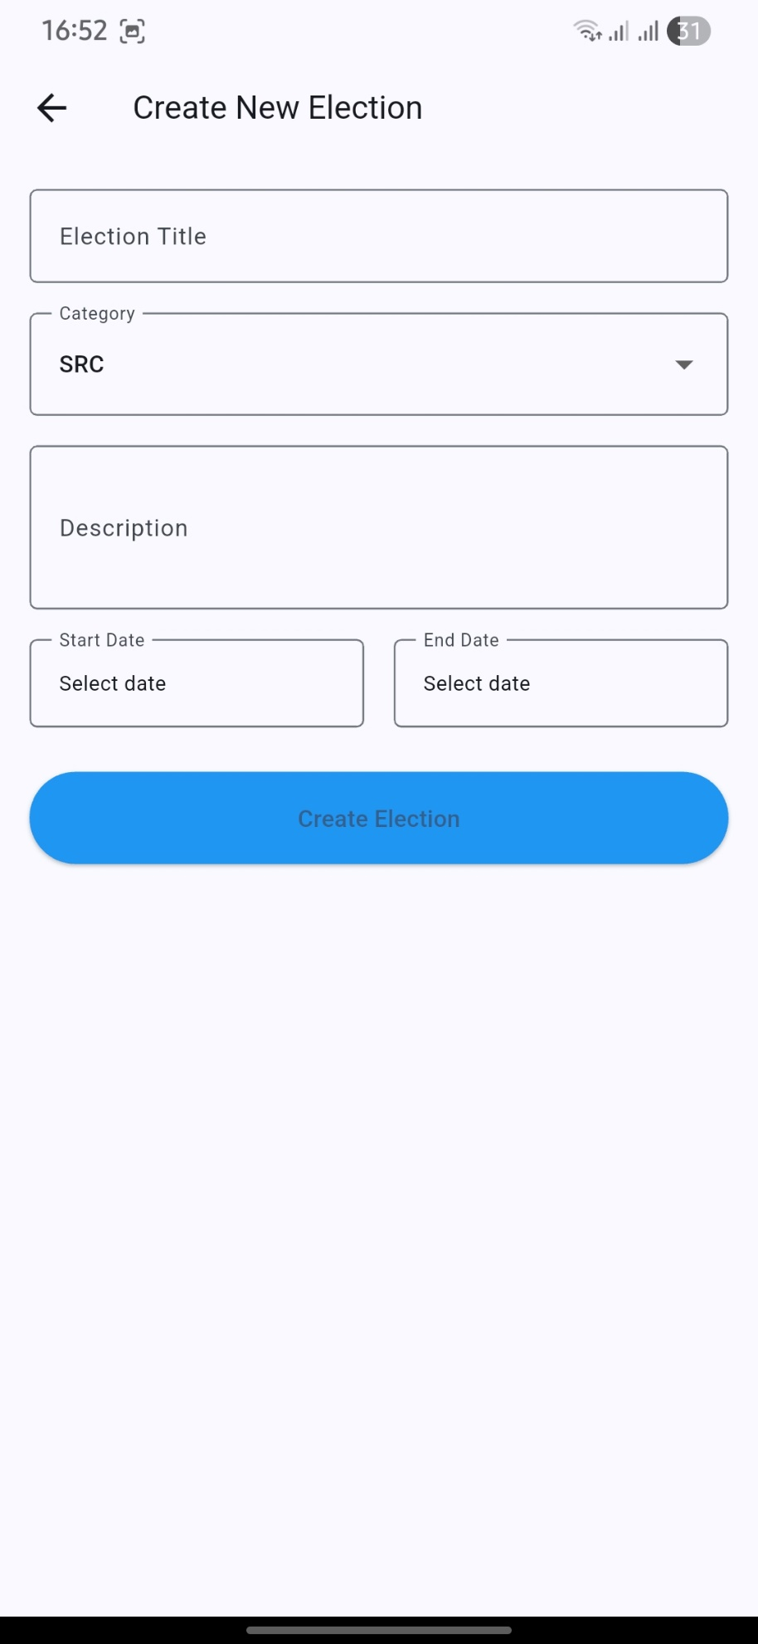
The admin clicks Create Election.
- Screen: Create New Election form.
- Inputs:
  - Election Title: (e.g., "SRC Elections 2026")
  - Category: A dropdown (e.g., "SRC").
  - Description: Details about the election.
  - Start Date & End Date: The voting period schedule.
- Outcome: The admin clicks Create Election to make the voting round live for students.

Step 4: Adding Candidates
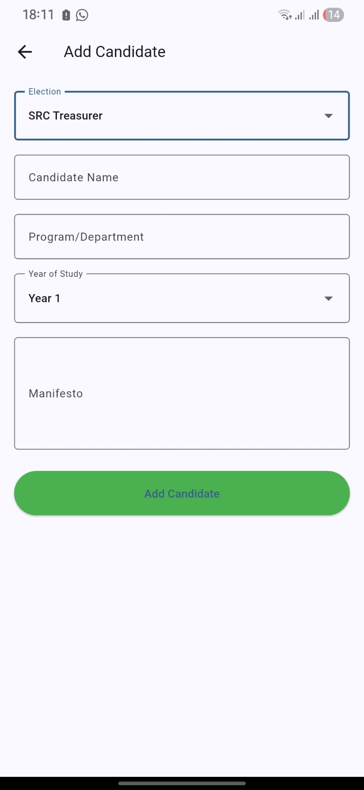
The admin clicks Manage Candidates.
- Screen: Displays the candidate roster for the selected election.
- Adding: The admin uses the Add Candidate form.
  - Election: Select the position (e.g., "SRC Treasurer").
  - Details: Enter Candidate Name, Program/Department, Year of Study, and their Manifesto.
- Monitoring: In the "Manage Candidates" view, the admin can see live vote counts per candidate (e.g., "Tawanda – Computer Science – 0 votes").

Step 5: Viewing Results
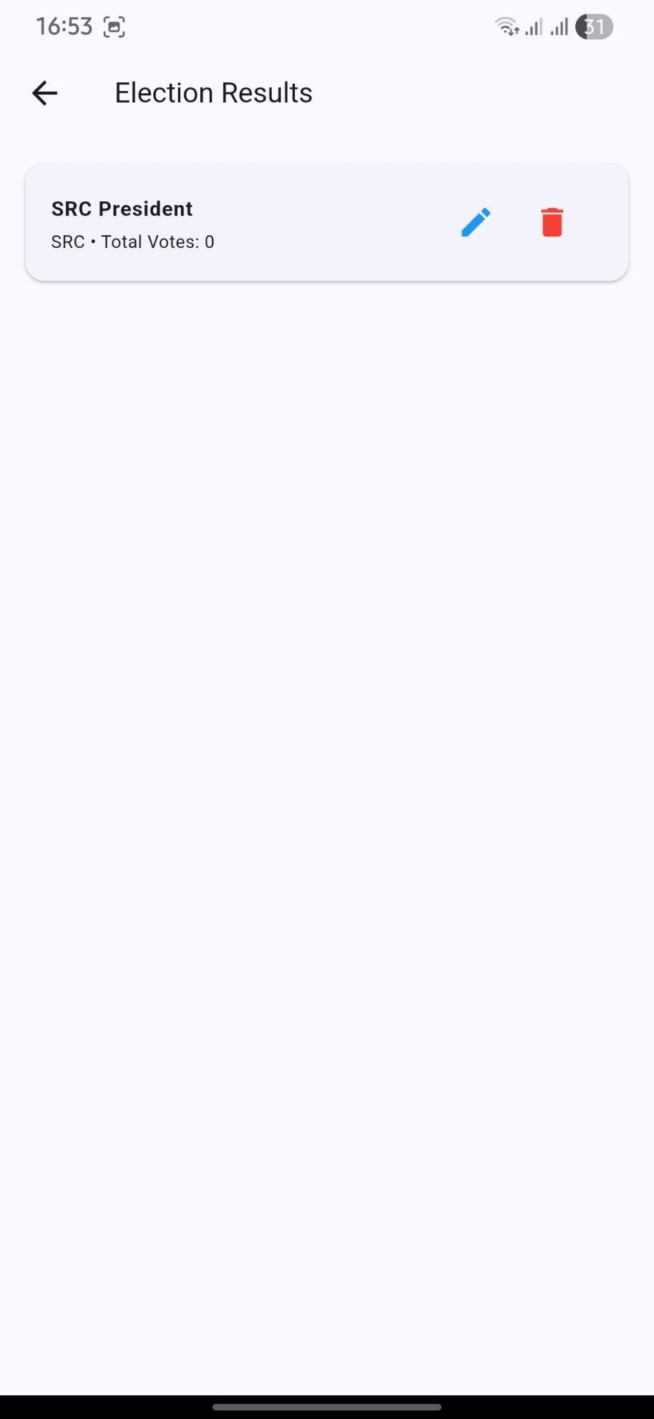
The admin clicks View Results or navigates to the results section.
- Screen: Election Results breakdown.
- Info Displayed:
  - Position (e.g., SRC President)
  - Category (SRC)
  - Total Votes cast for that position.

Summary Workflow:
- Admin creates an Election, sets dates, and adds Candidates.
- Student registers for an account.
- Student logs in, views the Dashboard/Policies, and navigates to the Voting section.
- Student selects a category and candidate, then casts their vote.
- Admin monitors the Results in real-time.

